U.S. Radiocommunications Sector
Fact Sheet
Working Party: USWP7C | Document No: USWP7C/27-042NC
Reference:  R23-WP7C-C-0142!N07!  WRC-27 AI 1.17 | Date:12 February 2025
Document Title: Working Document Towards A Preliminary Draft New Recommendation ITU-R RS.[RXSW_PROTECT_CRITERIA]
Author(s)/Contributors(s):  Philip Sohn  DOC/NOAA/NWS  Tomasz Wojtaszek  DOC/NOAA  Christopher Hough  DOC/NOAA  Edna Prado  DOC/NOAA | Phone: 301-427-9676  Email: philip.sohn@noaa.gov  Phone : 301-456-4574  Email : tomasz.wojtaszek@noaa.gov  Phone : 301-323-8212  Email : christopher.hough@noaa.gov  Phone : 301-628-5742  Email : edna.prado@noaa.gov
Purpose/Objective: To progress the work on developing the new Recommendation for protection criteria of receive-only space weather sensors operating in the meteorological aids service (space weather) in the frequencies that are listed under the WRC-27 Agenda Item 1.17.
Abstract:
The meeting of Working Party 7C (18-27 September 2024) updated the working document towards a preliminary draft new Recommendation on the protection criteria of receive-only space weather sensors operating in the frequencies that are listed under the WRC-27 Agenda Item 1.17. This contribution seeks to progress the work on developing this new ITU-R Recommendation by proposing further updates.
Fact Sheet Preparer: Philip Sohn

Radiocommunication Study Groups | 
Source: Document 7C/142 Annex 7  Subject: WDPN Recommendation ITU-R RS.[RXSW_PROTECT_CRITERIA] | Document 7C/XXX-E
 | TBD
 | English only
WORKING DOCUMENT TOWARDS A PRELIMINARY DRAFT NEW RECOMMENDATION ITU-R RS.[RXSW_PROTECT_CRITERIA]
Protection criteria of receive-only space weather sensors
in the meteorological aids service (space weather)
(20xx)
Scope
This Recommendation provides protection criteria which should be used for sharing and compatibility studies for receive-only space weather sensors operating in the meteorological aids service (space weather), abbreviated as MetAids (space weather).
Related ITU-R Recommendations and Reports
Report ITU-R RS.2456-1 – Space weather sensor systems using radio spectrum
Keywords
meteorological aids service, MetAids, space weather, receive-only space weather sensor
Abbreviations/Glossary
MetAids: Meteorological aids service
The ITU Radiocommunication Assembly,
considering
a) that Radio Regulations (RR) Article 29B and Resolution 675 (WRC-23) allow space weather sensors to operate under the meteorological aids service in the subset MetAids (space weather) allocations;
b) that it is necessary to specify the maximum allowable interference into receive-only space weather sensors operating in the MetAids (space weather) to ensure that those sensors can achieve adequate performance in the presence of interference;
c) that WRC-27 agenda item 1.17 proposes to consider regulatory provisions for receive-only space weather sensors and their protection in the Radio Regulations, taking into account the results of ITU Radiocommunication Sector studies, in accordance with Resolution 682 (WRC-23),
recommends
that the protection criteria given in Annex 1 should be used for sharing and compatibility studies for receive-only space weather sensors operating in the MetAids (space weather);

Annex 1
Protection criteria of receive-only space weather sensors
in the meteorological aids service (space weather)

1 Introduction
Space weather sensors, as defined in ITU-R Res. 675 (WRC-23), are operated globally that utilize the radio spectrum and provide data critical for forecasts and warnings of space weather events, in addition to data for research in order to better understand the underlying physical processes and to develop more reliable space weather models.
This Annex derives interference criteria for receive-only space weather sensors that operate in the MetAids (space weather) allocations:
27.5-28.0 MHz
29.7-30.2 MHz
32.2-32.6 MHz
37.5-38.325 MHz
73.0-74.6 MHz
608-614 MHz.
These criteria provide protection to space weather sensors from new entrants into these frequency ranges without imposing constraints on already allocated, incumbent services.
It needs to be noted that sensors and technical equipment for space weather observations are often not distinct and are simultaneously used for applications under other radio or radiocommunication services as well. However, the operational scheme of the sensor, its sensitivity and protection criteria, may deviate for applications in other services. Therefore, it needs to be noted that:
When operating in the service MetAids (space weather), the protection criteria for space weather observations defined in this document apply .
When operating under another radio or radiocommunication service, the sensors operate with the protection criteria and the corresponding status of that service.
With this approach, there will be no impact on observations performed with the same sensor equipment in other radio or radiocommunication services or on other operations in the MetAids service.

2 Riometers
A riometer is an instrument used to measure the relative opacity of the ionosphere by making precise measurements of the power of the cosmic radio noise radiated from celestial bodies or galactic sources. In light of the nature of these measurements, the minimum antenna noise temperatures used to calculate the interference level for the radiometer have been derived from those listed in Table 1 of Recommendation ITU-R RA.769-2 using linear interpolation. The integration time employed is 1 sec, which is considered typical for riometer observation. For bandwidth, 250 kHz is assumed.
Table 1 below provides the protection criteria for the typical operational frequencies identified in Report ITU-R RS.2456-1 as the potential frequency bands for the MetAids (space weather) allocation.
Table 1
Riometer protection criteria for typical operational frequencies
Frequency band  (MHz) | Frequency  fc  (MHz) | Bandwidth  Δf  (MHz) | Minimum antenna noise temperature  T_{A}  (K) | Receiver noise temperature  T_{R}  (K) | System sensitivity |  | Protection criteria
 |  |  |  |  | Temperature  ΔT  (mK) | Power spectral density  ΔP  (dB(W/Hz)) | Input power  ΔP_{H}  (dBW) | pfd  S_{H} Δf  (dB(W/m²)) | Spectral pfd  S_{H}  (dB(W/(m² · Hz)))
27.5-28.0 | 27.8 | 0.25 | 9400 | 200 | 19200 | ‒216 | ‒172 | ‒181 | ‒235
29.7-30.2 | 30.0 | 0.25 | 7900 | 200 | 16200 | ‒217 | ‒173 | ‒181 | ‒235
32.2-32.6 | 32.4 | 0.25 | 6700 | 200 | 13800 | ‒217 | ‒173 | ‒182 | ‒235
37.5-38.325 | 38.2 | 0.25 | 4600 | 200 | 9600 | ‒219 | ‒175 | ‒182 | ‒236
73.0-74.6 | 74.0 | 0.25 | 1000 | 200 | 2400 | ‒225 | ‒181 | ‒182 | ‒236

3 Solar flux monitors
The protection criteria for solar flux monitors could be established based on the minimum measurable solar flux value for a given frequency, not the receiver noise floor, which is typically lower. Report ITU-R RS.2456-1 indicates that protection criteria for solar flux monitors is determined using the following formula:
I_{max (pfd)} = SolarRadioFlux_{min} × Bandwidth × Precision (1)
where:
Imax (pfd) = maximum acceptable interference power flux density (W/m²)
SolarRadioFlux_{min} = typical solar radio flux observed at solar minimum, also indicated as quiet Sun (W/(m² ∙ Hz))
Bandwidth = bandwidth of the receiver (Hz)
Precision = precision of the measurement, up to 3 decimal positions. In general, a precision of 1% is required for the quiet Sun radio-astronomical observations (equivalent to 2 decimal position or –20 dB).
Table 5 in Report ITU-R RS.2456-1 provides the characteristics of a variety of solar flux monitors operated around the globe, providing data for space weather predictions and warnings. The typical solar radio flux at solar minimum can be based on data presented in Fig. 13 of Report ITU-R RS.2456-1, which is also replicated below in Fig. 1.
Figure 1
Typical minimum solar flux levels
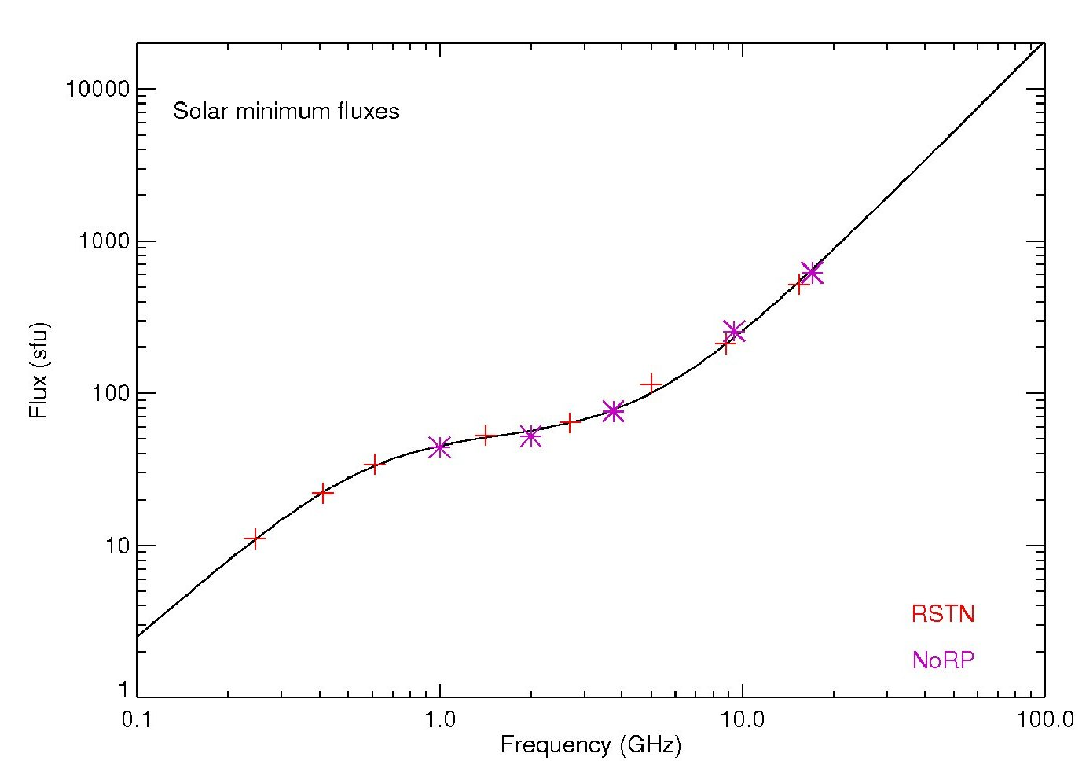
Table 2 presents values from Fig. 1 for frequencies that are used by solar radio flux monitors and identified in Resolution 682 (WRC-23).
Table 2
Minimum Solar Flux Levels for Solar Flux Monitor Operational Frequency
Frequency  (MHz) | Minimum solar flux  (SFU) | Minimum solar flux  (W/(m² ∙ Hz))
610 | 32 | 32 × 10⁻²²

Equation 1 above provides the maximum interference level in terms of a power flux density. Taking the antenna into account, the maximum interference threshold becomes:
I_{max} = I_{max (pfd)} × A_{e} (2)
where:
I_{max} = maximum acceptable interference level (W)
I_{max (pfd)} = maximum acceptable interference power flux density (W/m²)
A_{e} = antenna effective aperture (m²).
Antenna effective aperture is calculated with the following equation:
A_{e} = G λ² / 4π (3)
where:
A_{e} = antenna effective aperture (m²)
G = antenna gain
λ = wavelength for frequency of operation (m).
Since protection criteria is dependent upon antenna effective aperture, the values for each system will be different.
It should be noted that the maximum acceptable interference level I_{max} provided in equation (2) is calculated on the assumption that the interference is received through the antenna sidelobes of the solar flux monitor. However, there are some other cases of interference coming into or near the antenna main beam direction. For example, the geostationary-satellite orbit overlaps the apparent solar direction in spring and autumn, which lead to significant interference from the geostationary satellites. In these cases, the calculation for protection criteria should take into account the antenna gain level in the direction of arrival of the interference.
Table 3 provides the site names, locations and characteristics (frequency, antenna gain, etc.) of individual single-frequency solar radio flux measurement systems. It should be noted that this table now includes only the systems operating in the frequency bands under the WRC-27 agenda item 1.17, which at this time is the RSTN-RIMS operating at 610 MHz. It should also be noted that the protection criteria is now represented in terms of power flux density, in accordance with the Equation 1 above, 10 × log(32 × 10-22 (W/(m² ∙ Hz)) × 106 (Hz) × 0.01) = –164.9 dB(W/(m² ∙ MHz)).
.

Table 3
Solar flux monitor protection criteria for some receiving system parameters
Site name | Latitude | Longitude | Frequency  (MHz) | Antenna  gain (dBi) | Receive BW  (MHz) | Effective aperture  (m²) | Protection criteria¹  (dBW/(m² ∙ MHz)
Learmonth (SEON)  San Vito (SEON)  Sagamore Hill (SEON)  Kaena Point (SEON) | 22.2192°S  40.6°N  42.6323°N  21.5614°N | 114.103°E  17.8°E  70.8201°W  158.2392°W | 610 | 32.5 | 6 | 34.23 | -164,9
¹ Power flux density at the antenna.

4 Spectrometers
{Editor’s note: More discussion is needed given that the spectrometers operate over broad frequency ranges and the calculation of protection criteria at discrete operating frequencies is not practical per RS.2456.}
Solar spectrometers measure radio emission levels from the sun across much wider bandwidths in comparison to solar flux monitors. The methodology for calculating protection criteria is the same as that used for solar flux monitors, however the frequencies and bandwidths will differ from solar flux monitors. The minimum solar flux levels shown in Fig. 1 apply.
Table 4 presents an equation for estimating the minimum solar flux levels for continuous frequency ranges. Since spectrometers operate over broad frequency ranges, calculation of protection criteria at discrete operating frequencies is not practical.
{Editor’s note: the units and formulas provided in Tables 4 and 5 need to be reviewed for next WP7C meeting. (need to take in consideration the following parameters to derive the protection criteria will be proposed:(Frequency range of operation - Band width- Receive sensitivity and band width – Antenna main beam Gain - Antenna Pattern))}.
Table 4
Equations for minimum solar flux
Frequency range  (MHz) | Minimum solar flux equation  (W/(m² · MHz)) | Values for SL and IP
27.5-28 | ${SolarFlux}_{min}$ $= \left({10}^{\left(\left(SL *\log\left(f\right)\right)+ IP\right)}\right)* {10}^{-22}$  where f is the observation frequency in MHz | SL = 1.992; IP=-3.7122
29.7-30.2
32.2-32.6
37.5-38.325
73-74.6
608-614 |  | SL = 1.058; IP = −1.441

Table 5
Equations for calculating solar spectrometer protection criteria
Frequency range  (MHz) | Equation for protection criteria  (dBW/(m².MHz)) | Values for SL and IP
27.5-28 | $I_{max}$ $=10*\log\left(G\frac{λ2}{4π} ×{SolarFlux}_{min} × BW × P\right)$  where:  ${SolarFlux}_{min}$ $= \left({10}^{\left(\left(SL *\log\left(f\right)\right)+ IP\right)}\right)* {10}^{-22}$  f is observation frequency in MHz  G is sensor antenna gain  BW is sensor bandwidth  P is required precision. | SL = 1.992; IP=-3.7122
29.7-30.2
32.2-32.6
37.5-38.325
73-74.6
608-614 |  | SL = 1.058; IP = −1.441

5 IPS
{Editor’s note: Information needs to be provided regarding the operational system in the frequency bands under study}

6 Summary
The information in this document can be used for future sharing and compatibility studies for receive-only space weather sensors operating in the frequency ranges specified in the introduction section.
For sensors performing solar observations, solar flux monitors and solar spectrometers, the system sensitivity, based on the minimum measurable solar flux level, combined with the sensor measurement resolution, is above the receiver noise level. Therefore, for those sensor types the protection criteria is established using the solar flux minimum levels produced by the sun, rather than the sensor receiver noise level.

